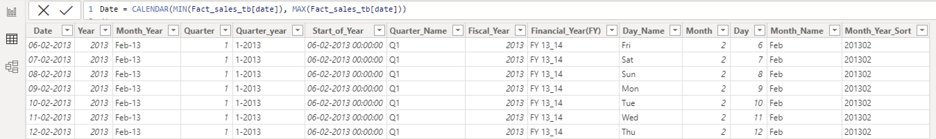

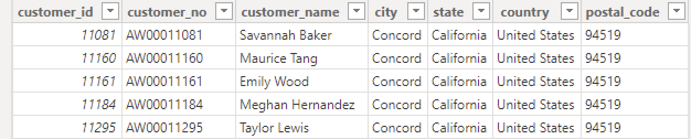

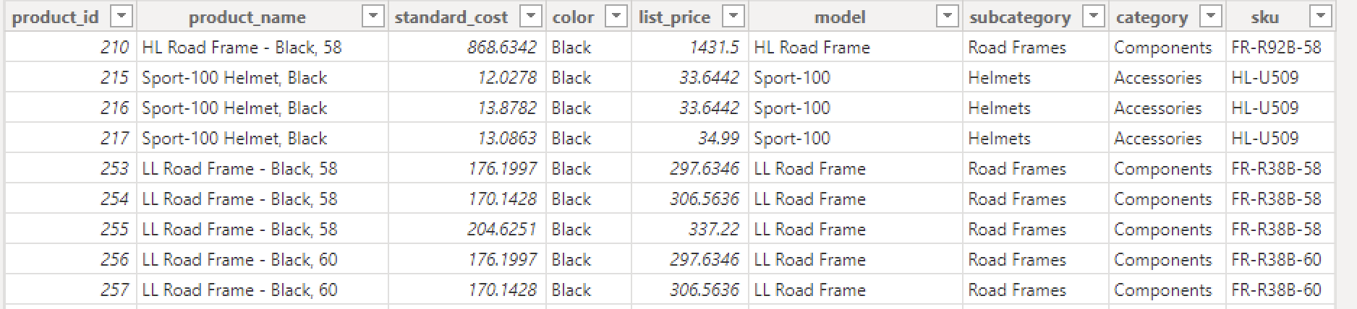

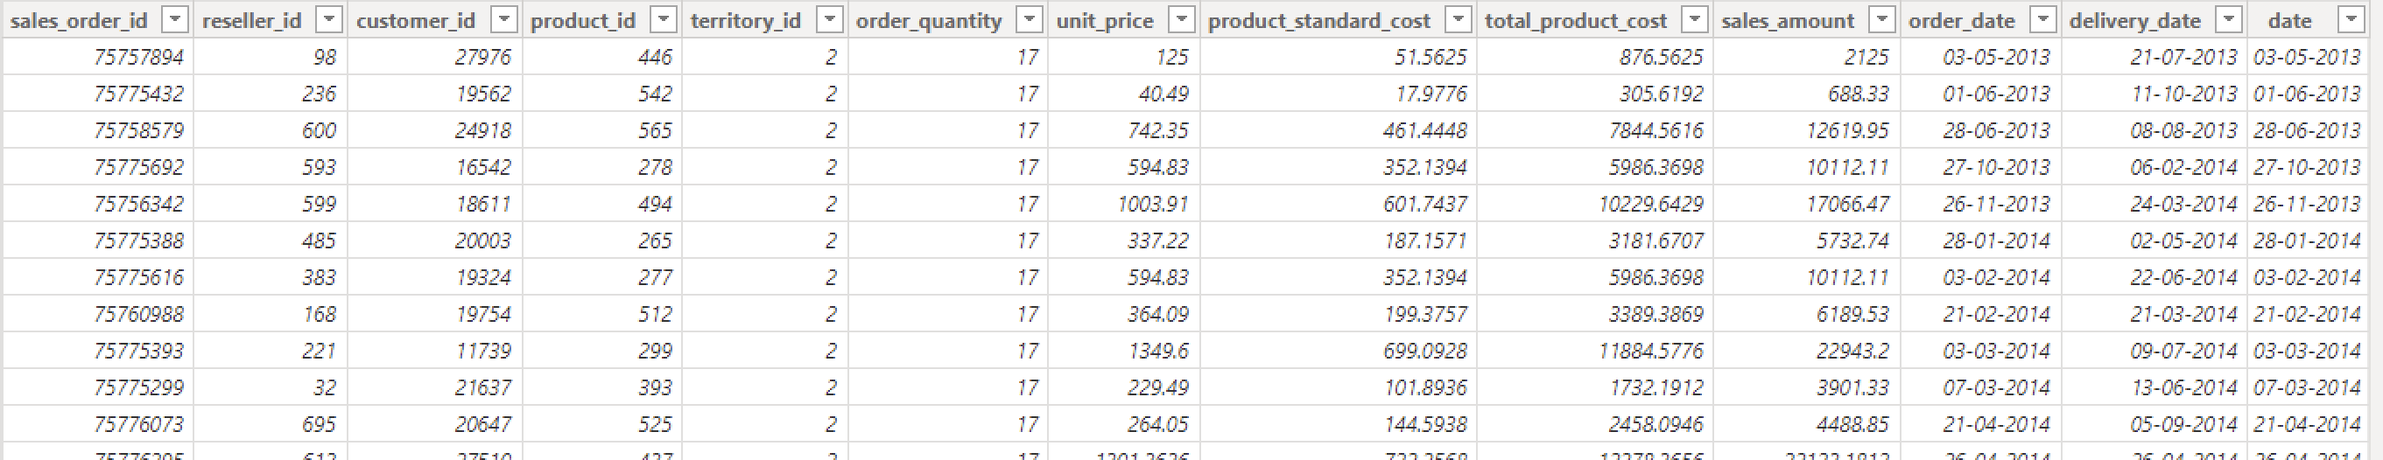

DATE TABLE - NEW COLUMNS

Date = CALENDAR(MIN(Fact_sales_tb[order_date]), MAX(Fact_sales_tb[order_date]))

or

Date = CALENDARAUTO(3) // 3 - FiscalYearEndMonth (Calendar will start from 1st April-31st March)

or

Date = CALENDAR(MIN(Fact_sales_tb[order_date]), MAX(Fact_sales_tb[order_date]))

/*

VAR

start_Date = MIN(Fact_sales_tb[order_date])

VAR

end_Date = MAX(Fact_sales_tb[order_date])

VAR

date_Table = CALENDAR(start_Date, end_Date)

RETURN

ADDCOLUMNS(date_Table,

"Month", MONTH([Date]),

"Year", YEAR([Date]),

"Quarter", QUARTER([Date]),

"Week_No", WEEKNUM([Date], 1), //1- Sunday, 2-Monday (Week starts from Sunday or Monday)

"Month_Name", FORMAT([Date], "MMM"),

"Month_Year", FORMAT([Date], "MMM-yyyy"),

)

*/

Start_of_Year = STARTOFYEAR('Date'[Date], "31/03")

Fiscal Year = YEAR('Date'[Start_of_Year])

Financial_Year(FY) = "FY " & RIGHT('Date'[Fiscal Year], 2) &"_"& RIGHT('Date'[Fiscal Year]+1, 2)

Day = DAY('Date'[Date])

Day_Name = FORMAT(DAY('Date'[Date]), "DDDD")

Today_Date = TODAY()

Today_Day = FORMAT([Today_Date], "DDDD")

Week_Day = WEEKDAY(TODAY(),2) // 2-Week start from Monday

Week_No = WEEKNUM(TODAY())

Month = MONTH('Date'[Date])

Month_Name = FORMAT([Date], "MMM")

Month_Year = FORMAT('Date'[Date], "MMM-yy")

Month_Year_Sort = FORMAT('Date'[Date], "YYYYMM")

Quarter = QUOTIENT(DATEDIFF('Date'[Start_of_Year], 'Date'[Date], MONTH), 3)+1 // Takes APR-MAY-JUNE -> Q1

Quarter_Name = "Q"&'Date'[Quarter]

Quarter_year = 'Date'[Quarter]&"-"&'Date'[Year]

Year = YEAR('Date'[Date])

CALCULATED MEASURES

__________________________________________________________________________________________________________________________

Total_Sales = SUM(Fact_sales_tb[sales_amount])

Today_Sales = CALCULATE([Total_Sales], FILTER('Date', 'Date'[Date] = TODAY()))

//CALCULATE([Total_Sales], LASTDATE('Date'[Date]))

Yesterday_Sales = CALCULATE([Total_Sales], FILTER('Date', 'Date'[Date] = TODAY()-1))

//CALCULATE([Total_Sales], LASTDATE('Date'[Date]))

Avg_Daily_Sales = AVERAGEX(VALUES('Date'[Date]), [Total_Sales])

Week_To_Date_Sales =

VAR

_min = today() -WEEKDAY(today() ,2) +1 //Monday week start

VAR

_max = _min +6

RETURN

CALCULATE([Total_Sales], FILTER('Date','Date'[Date] >=_min && 'Date'[Date] <= _max))

MTD Sales = TOTALMTD([Total_Sales], 'Date'[Date])

PM MTD Sales =

VAR

PM_Sales = CALCULATE([Total_Sales], PREVIOUSMONTH('Date'[Date]))

RETURN

IF(ISBLANK(PM_Sales), 0, PM_Sales)

PY MTD Sales = TOTALMTD([Total_Sales], SAMEPERIODLASTYEAR('Date'[Date]))

Avg_Daily_Sales_MTD = CALCULATE(Average(Fact_sales_tb[sales_amount]),DATESMTD('Date'[Date]))

QTD Sales = TOTALQTD([Total_Sales], 'Date'[Date])

PY QTD Sales = TOTALQTD([Total_Sales], SAMEPERIODLASTYEAR('Date'[Date]))

Avg_Daily_Sales_QTD = CALCULATE(Average(Fact_sales_tb[sales_amount]),DATESQTD('Date'[Date]))

YTD Sales = TOTALYTD([Total_Sales], 'Date'[Date], "31/03")

PY YTD Sales = TOTALYTD([Total_Sales], SAMEPERIODLASTYEAR('Date'[Date]), "31/03")

Avg_Daily_Sales_YTD = CALCULATE(Average(Fact_sales_tb[sales_amount]),DATESYTD('Date'[Date], "31/03"))

Total_Cost = CALCULATE(SUM(Fact_sales_tb[total_product_cost]))

Profit = [Total_Sales] - [Total_Cost]

Profit % = [Profit]/[Total_Sales]

MTD Profit = TOTALMTD([Profit], 'Date'[Date])

MTD Profit % = [MTD Profit]/[MTD Sales]

PY MTD Profit = TOTALMTD([Profit], SAMEPERIODLASTYEAR('Date'[Date]))

PY MTD Profit % = [PY MTD Profit]/[PY MTD Sales]

QTD Profit = TOTALQTD([Profit], 'Date'[Date])

QTD Profit % = [QTD Profit]/[QTD Sales]

PY QTD Profit = TOTALQTD([Profit], SAMEPERIODLASTYEAR('Date'[Date]))

PY QTD Profit % = [PY QTD Profit]/[PY QTD Sales]

YTD Profit = TOTALYTD([Profit], 'Date'[Date], "31/03")

YTD Profit % = [YTD Profit]/[YTD Sales]

PY YTD Profit = TOTALYTD([Profit], SAMEPERIODLASTYEAR('Date'[Date]), "31/03")

PY YTD Profit % = [PY YTD Profit]/[PY YTD Sales]

CAGR = (

VAR

Beginning_Value = CALCULATE(SUM(Fact_sales_tb[sales_amount]),FILTER('Fact_sales_tb', YEAR('Fact_sales_tb'[order_date]) = MIN('Date'[Fiscal_Year])))

VAR

Ending_Value = CALCULATE(SUM(Fact_sales_tb[sales_amount]),FILTER('Fact_sales_tb', YEAR('Fact_sales_tb'[order_date]) = MAX('Date'[Fiscal_Year])))

VAR

No_Of_Years = (MAX('Date'[Fiscal_Year])-MIN('Date'[Fiscal_Year]))

RETURN

CALCULATE((Ending_Value/Beginning_Value)^(1/No_Of_Years)-1)

)

Avg_Monthly_Sales = AVERAGEX(VALUES('Date'[Month_Year]), [Total_Sales])

Avg_Yearly_Sales = AVERAGEX(VALUES('Date'[Financial_Year(FY)]), [Total_Sales])

Total_Orders = COUNTROWS(Fact_sales_tb)

Today_Orders = CALCULATE([Total_Orders], FILTER('Date', 'Date'[Date]=TODAY()))

//CALCULATE(COUNTROWS(Fact_sales_tb), LASTDATE('Date'[Date])))

Week_To_Date_Orders =

VAR

_min = today() -WEEKDAY(today() ,2) +1 //Monday week start

VAR

_max = _min +6

RETURN

CALCULATE([Total_Orders], FILTER('Date','Date'[Date] >=_min && 'Date'[Date] <= _max))

Yesterday_Orders = CALCULATE(COUNTROWS(Fact_sales_tb), FILTER('Date', 'Date'[Date] = TODAY()-1))

//CALCULATE([Total_Sales], LASTDATE('Date'[Date]))

MTD Orders = TOTALMTD(COUNTROWS(Fact_sales_tb), 'Date'[Date])

PM MTD Orders =

VAR

PM_Orders = CALCULATE([Total_Orders], PREVIOUSMONTH('Date'[Date]))

RETURN

IF(ISBLANK(PM_Orders), 0, PM_Orders)